Lara Eunice A. Pacumio

2011-27228

2.

(a) Screenshots of codes

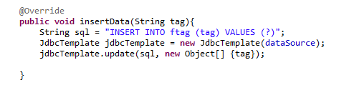

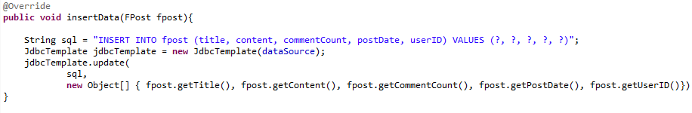

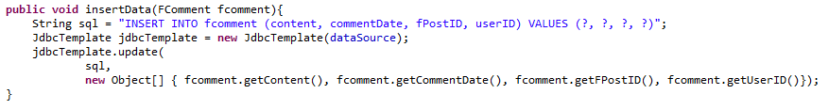

(b)

All of these are vulnerable to SQL injection. An attacker may insert an SQL statement (for example DELETE entire database) and this part of the code will run that, and thus, the entire database may be deleted.

(c)

For SQL injection, the best practice is to use prepared statements or stored procedures so that the input of the user will be checked and an attacker will not be able to insert SQL commands.